**Getting Started Analyzing Data in Python**

**TOTAL POINTS 2**

1.Question 1

What will be the result of the following line of code? **df.dtypes**



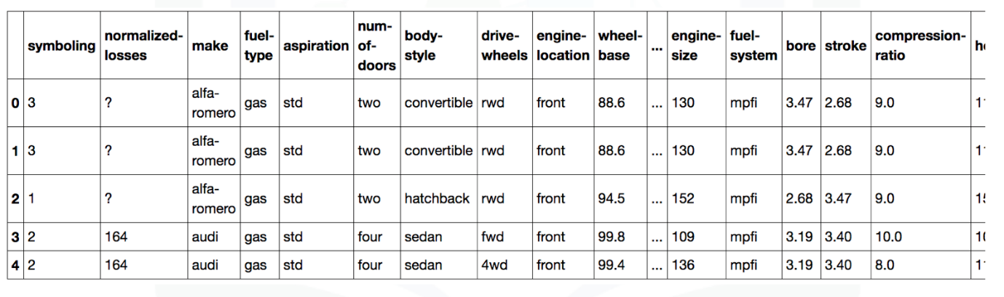

a)



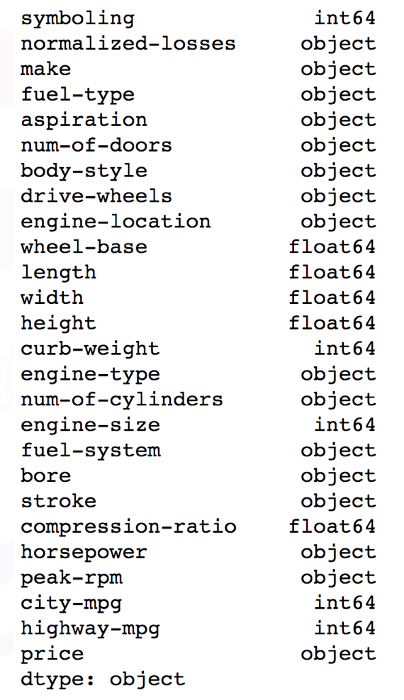

b)

1 point

2.Question 2

To enable a summary of all the columns, what must the parameter**include** be set to for the method **describe?**





1

df.describe(include=“all”)





1

df.describe(include=“None”)

1 point